Software Requirement Specification Document
For

Driver Drowsiness Detection System

Prepared by
Name: - ARYAN JHA
Reg No.: - 24BCA7498

School of Computer Science and Engineering


Date Created:13/12/25

- Introduction
  - Purpose
Table of Contents

Page Numbers

  - Intended Customers/Users
  - Product Scope
  - Outline of the document
- Overall Description
  - Product Perspective
  - Product Functions
  - User Classes
  - Design and Implementation Constraints
- Diagrams
  - UML Diagrams
  - ER Diagrams
  - DFD Diagrams
  - Assumptions and Dependencies
- External Interface Requirements/Screenshots
  - User Interfaces
  - Hardware Interfaces
  - Software Interfaces
  - Communication Interfaces
- Other Non-Functional Requirements
  - Performance Requirements
  - Safety Requirements
  - Security Requirements
  - Software Quality Attributes
  - Business Policies/Rules (if any)
- Testing
  - Block-Box Testing
  - White-Box Testing
- Design Architecture of System
- Conclusion
- Product Metrics/Function Point Analysis
- Empirical Estimation Models (COCOMO)
- References
- Acknowledgements

1. Introduction
The Driver Drowsiness Detection System (DDDS) is a safety solution built on computer vision technology. Its main job is to monitor a driver’s alertness level in real-time using a standard webcam. By continuously tracking eye movements and mapping facial landmarks, the system can spot the early signs of fatigue or drowsiness. If the software notices that the driver’s eyes are closed for too long—a condition known as microsleep—it immediately triggers an alert to prevent a potential crash. This project tackles one of the biggest causes of road accidents globally: driver fatigue. By issuing real-time warnings through loud alarms, hardware buzzers, or even SMS notifications, the system is designed to improve road safety and lower the risk of accidents.

1.1 Purpose
This Software Requirements Specification (SRS) document serves as a complete guide to the Driver Drowsiness Detection System. The goal of this document is to explain:
- How the system functions and what it aims to achieve.
- The functional and non-functional requirements needed to build it.
- Any constraints, assumptions, or limitations we are working with.
- The interfaces involved and the testing strategies we will use.
Basically, this SRS acts as the primary reference point for developers, evaluators, and instructors throughout the design, coding, and grading phases of the project.

1.2 Intended Customers / Users
The people who will interact with or benefit from this system include:
- Drivers: The main users. They are the ones being monitored and will receive the wake-up alerts if they start dozing off.
- Vehicle Owners: People who want to ensure their car is being driven safely, even if they aren't the ones behind the wheel.
- Family Members / Emergency Contacts: In more advanced setups, these people receive SMS or WhatsApp notifications if the driver is in a critical state of fatigue.
- Researchers & Students: Those looking to study or improve upon computer vision and AI applications in transportation safety.

1.3 Product Scope
The scope of the Driver Drowsiness Detection System covers:
- Capturing live video feed through a webcam.
- Detecting faces and eyes using specific facial landmark points.
- Calculating the Eye Aspect Ratio (EAR) to determine if eyes are open or closed.
- Sounding an audible alarm when drowsiness is detected.
- Integrating a hardware buzzer using an Arduino.
- Sending emergency alerts via SMS/WhatsApp using the Twilio API.

1.4 Outline of the Document
The rest of this document is structured as follows:
- Introduction: A quick look at the goals and objectives.
- Overall Description: How the system fits into the real world, its functions, and its users.
- Diagrams: Visual representations like UML, ER, and DFDs.
- External Interfaces: How the software talks to users, hardware, and other software.
- Non-Functional Requirements: Standards for performance, safety, and quality.
- Testing: The plan for verifying that everything works correctly.
- Conclusion and References.

2. Overall Description

2.1 Product Perspective
The Driver Drowsiness Detection System is designed as a standalone desktop application. It runs on a standard laptop or computer that is connected to a webcam. Under the hood, it relies on pre-trained machine learning models and computer vision libraries to process facial features on the fly. The system needs to interact with:
- A Webcam: To get the video input.
- The Local System: To process the data and generate the audio alerts.
- Optional Hardware: Such as an Arduino kit with a buzzer.
- Optional Services: Third-party APIs like Twilio for sending text messages.

2.2 Product Functions
The core capabilities of the software are:
- Video Capture: Constantly reading frames from the live video feed.
- Face Detection: Locating the driver's face within the frame.
- Landmark Identification: Pinpointing the specific coordinates of the eyes using a pre-trained model.
- EAR Calculation: mathematically computing the Eye Aspect Ratio to judge how open the eyes are.
- Drowsiness Logic: Recognizing when eyes have been closed for a dangerous amount of time.
- Alert System: Triggering sounds, buzzers, or messages to wake the driver.
- Logging: Keeping a simple record of when drowsiness events occurred.

2.3 User Classes
- Driver (Primary User):
  - The person sitting in the driver’s seat.
  - Their only role is to drive and respond to the audio/visual warnings if they get tired.
- System Administrator (Developer):
  - The person who sets up the software.
  - Responsible for tweaking sensitivity thresholds (like how long eyes must be closed to trigger an alarm) and maintaining the code.

- Emergency Contact:
  - The person designated to receive automated messages if the driver is repeatedly falling asleep.

2.4 Design and Implementation Constraints
- Lighting: The camera needs decent lighting to accurately detect facial landmarks; pitch darkness will cause it to fail.
- Hardware: A working webcam is mandatory.
- Performance: The computer must be fast enough to process video frames in real-time without lagging.
- Connectivity: Internet access is only needed if the SMS/WhatsApp alert feature is enabled.
- Integration: If using the physical buzzer, the correct Arduino drivers and ports must be configured.

3. Diagrams
3.1 UML Diagrams
1.) Use-Case Diagram
Module 1: Driver Detection Module
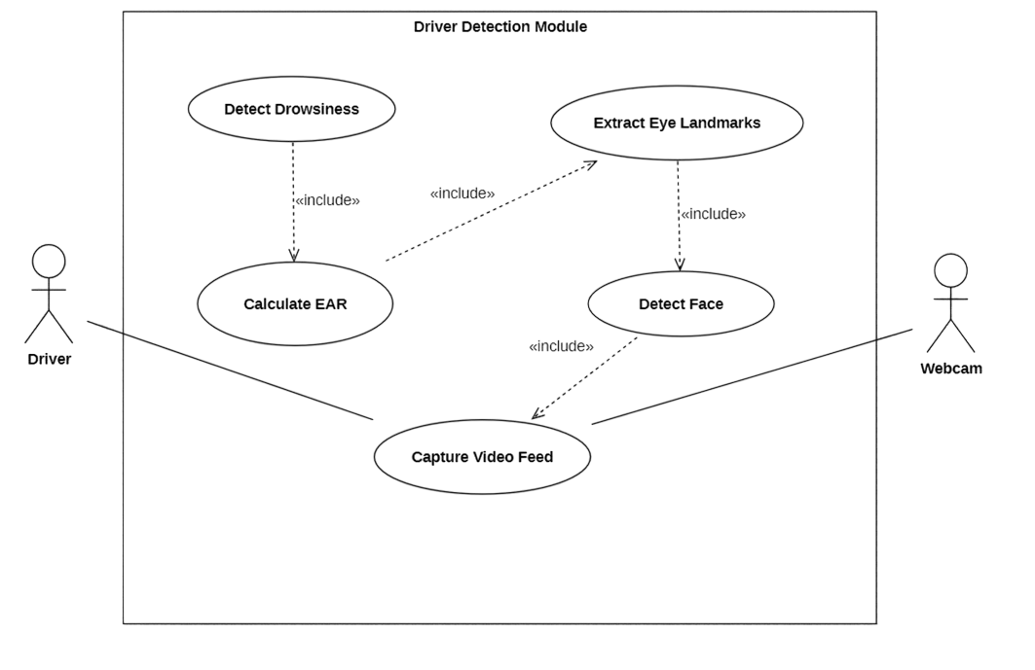

Module 2 : Alert and Notification Module
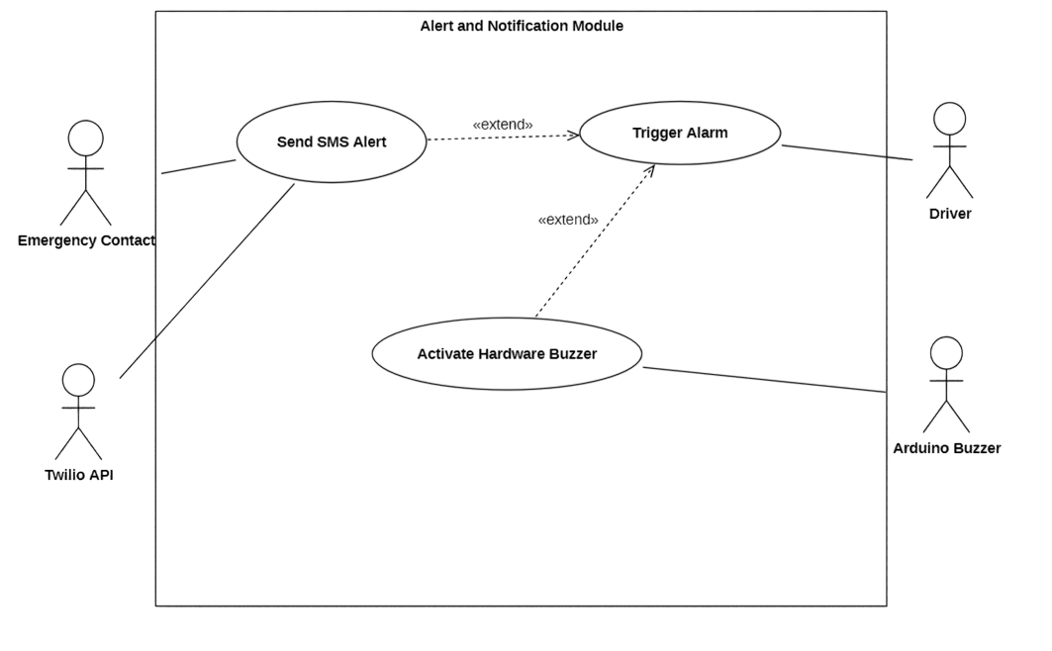

Module 3 : Advanced Monitoring Module

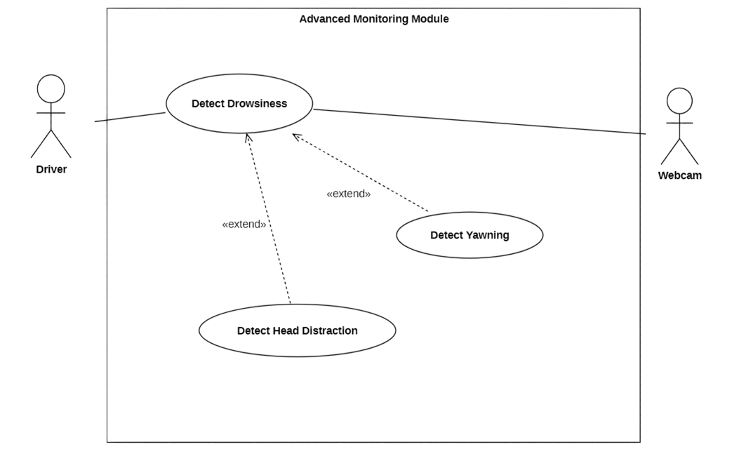

2.) Class Diagram

Module 1: Driver Detection Module

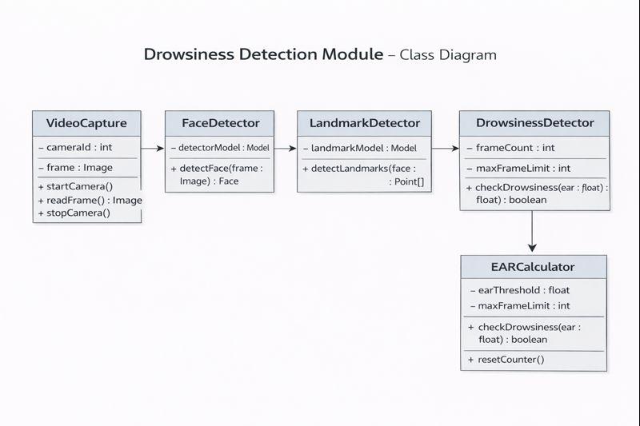

Module 2 : Alert and Notification Module

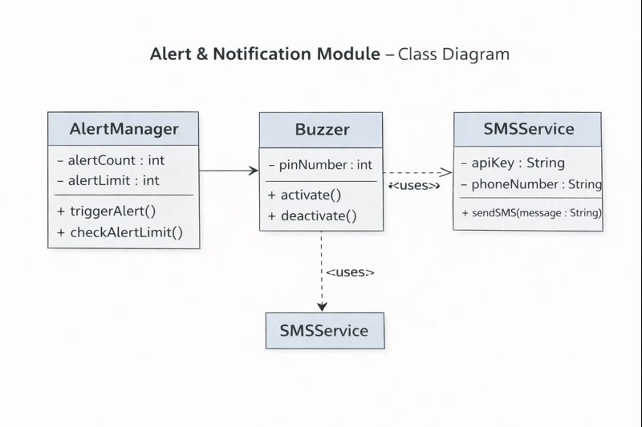

Module 3: Advanced Monitoring Module

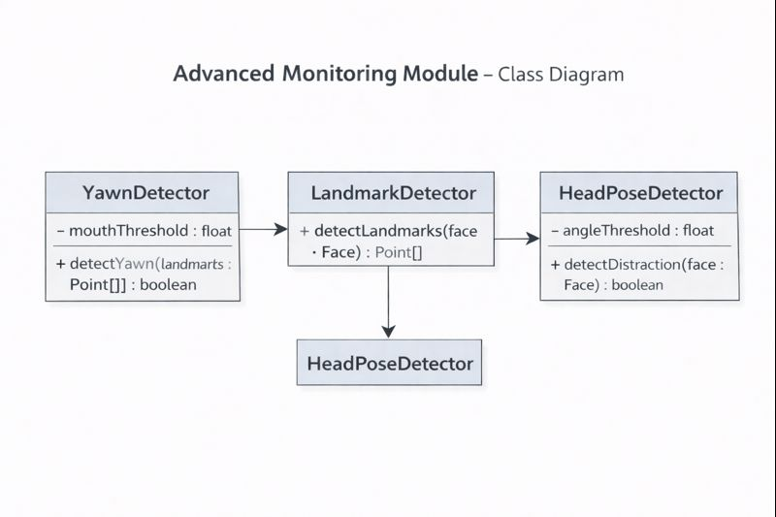
3) State – Chart Diagram:-

Screen Capture:

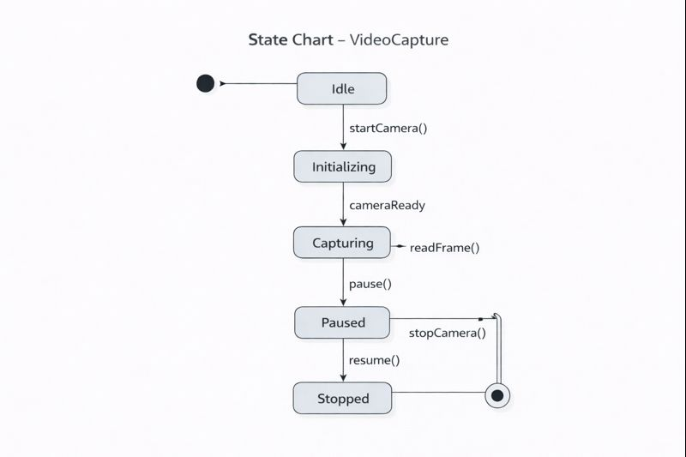

Face Detector:

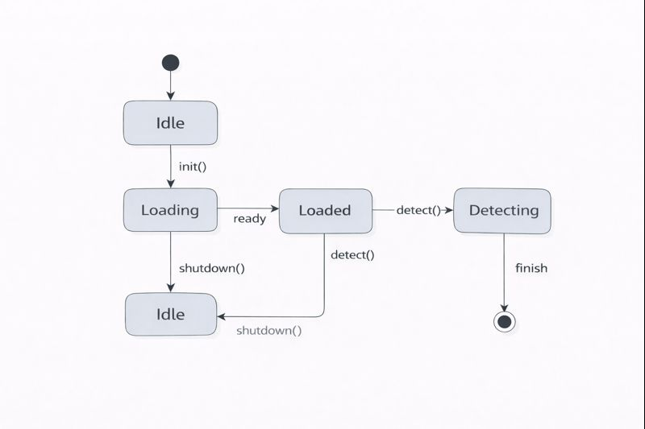

Drowsiness Detector:

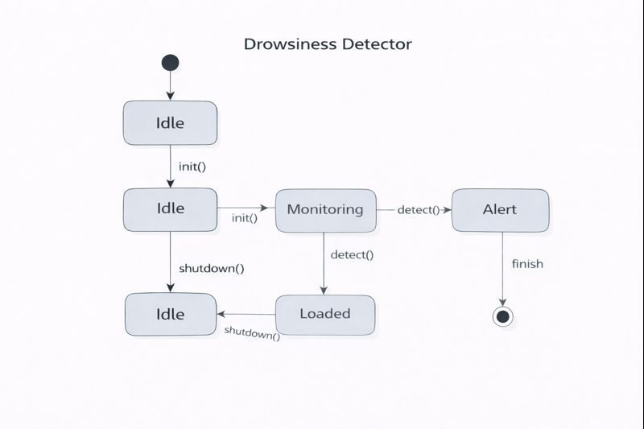

EAR Calculator:



4.) Activity Diagram:-

Module 1: Drowsiness Detection Module

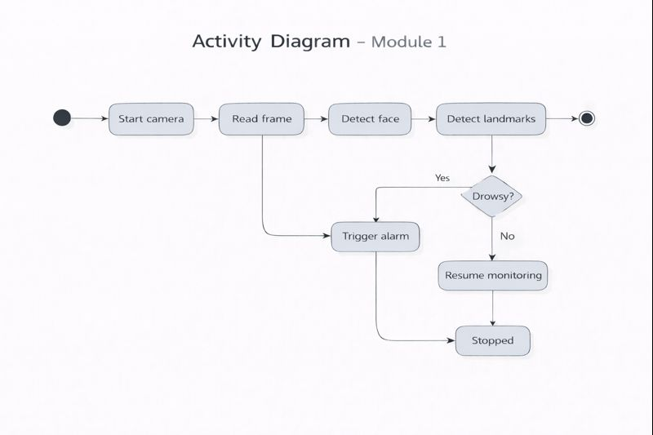

5.) Sequence Diagram: -

Module 1: Drowsiness Detection Module

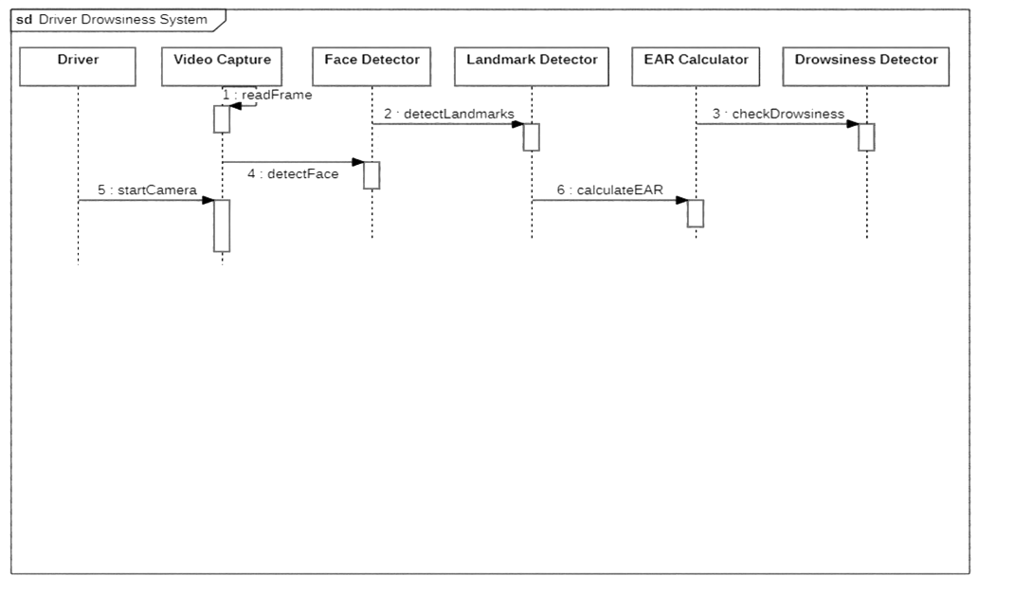

Module 2 : Alert and Notification Module

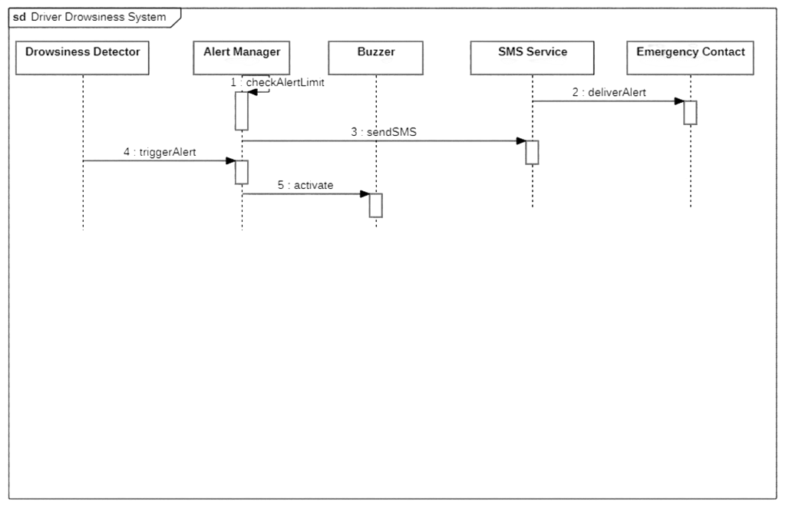

Module 3: Advanced Monitoring Module

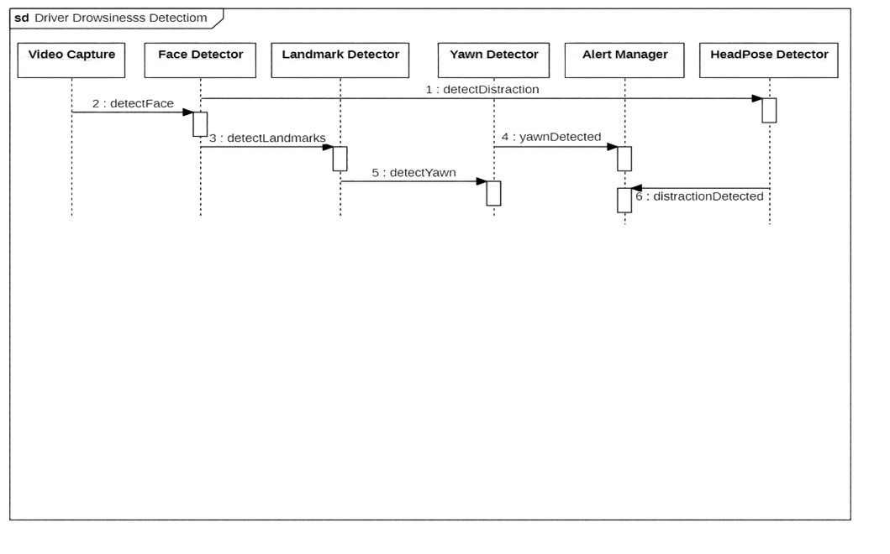

6.) Collaboration Diagram:-

Module 1: Drowsiness Detection Module

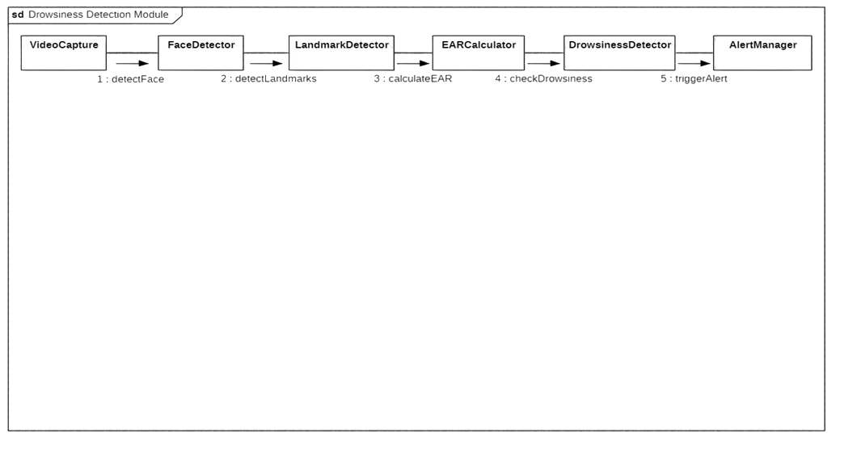

Module 2: Alert and Notification Module

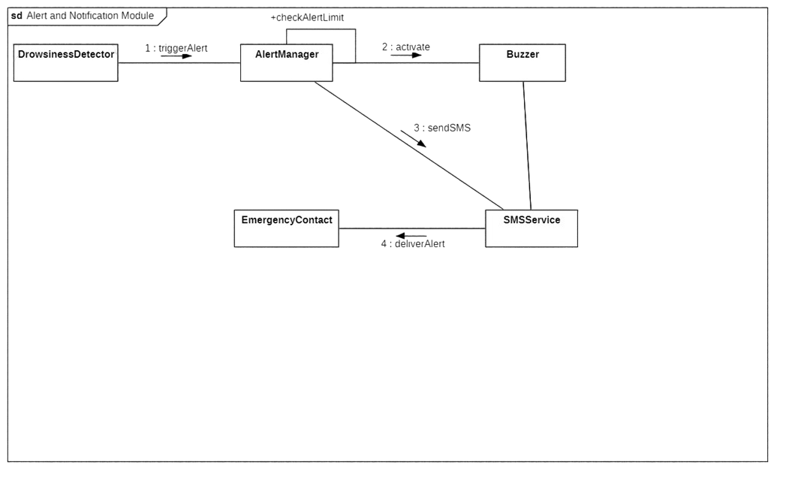

Module 3: Advanced Monitoring Module

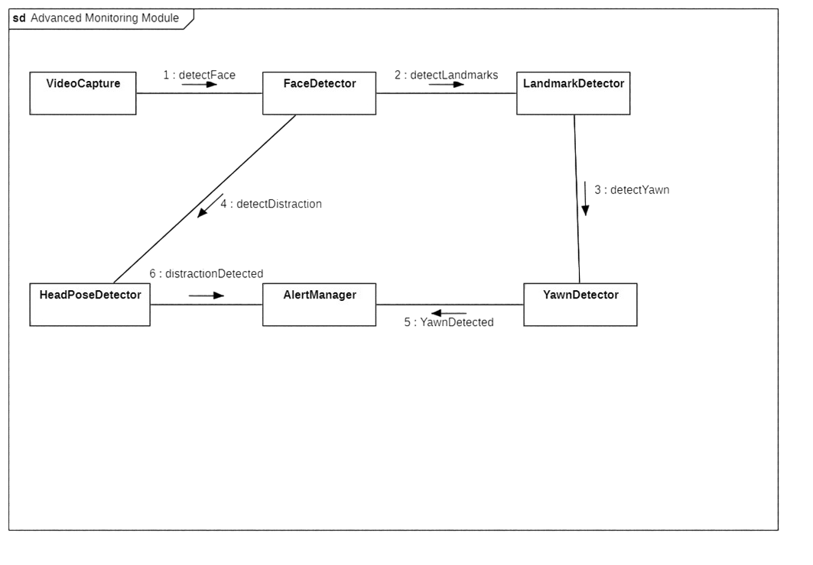

3.2 ER Diagram: -

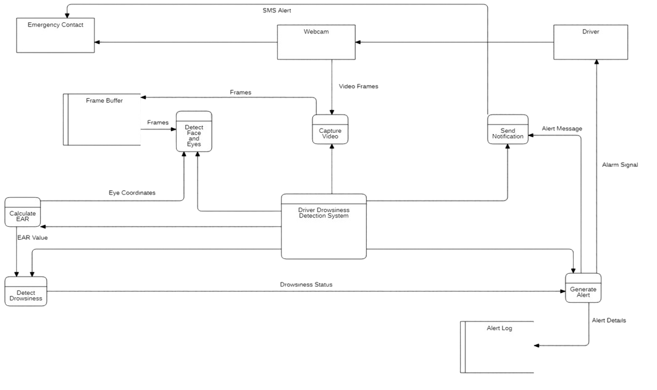

3.3 Data Flow Diagram (DFD): -

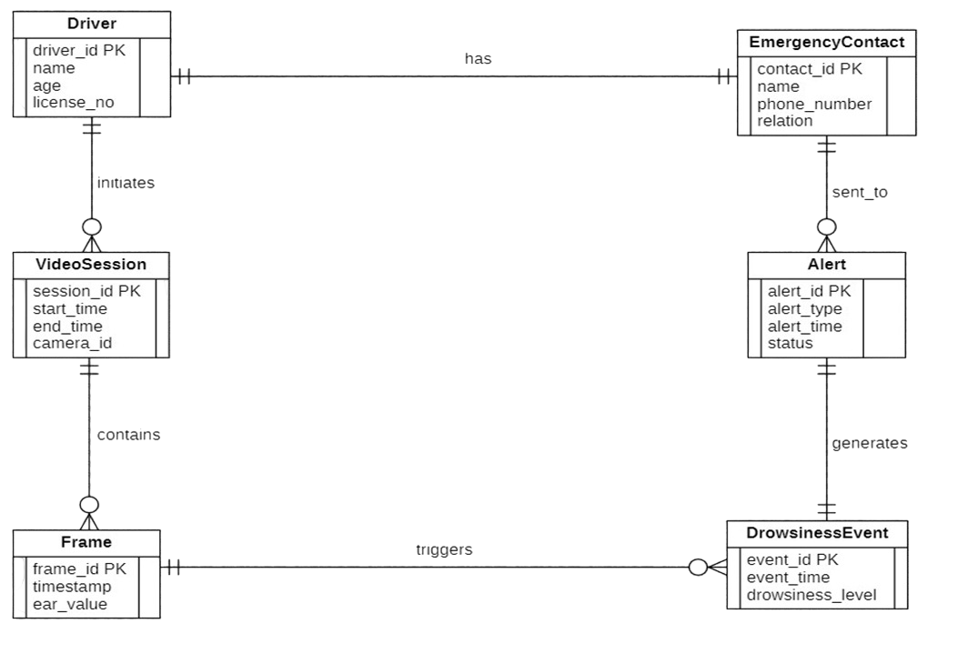3.4 Assumptions and Dependencies

The design and functioning of the Driver Drowsiness Detection System are based on a few assumptions and external dependencies.

It is assumed that the driver’s face is clearly visible to the webcam during operation. Proper lighting conditions are required for accurate facial landmark detection, as very low light or extreme glare may reduce detection accuracy. The system also assumes that the webcam is positioned correctly and remains stable throughout the driving session.

The system depends on certain hardware and software components to work correctly. A functional webcam is mandatory for video capture. If the Arduino-based buzzer is used, proper drivers and serial communication support must be available. Internet connectivity is required only when SMS or WhatsApp alert features are enabled. The accuracy of the system also depends on the reliability of pre-trained facial landmark models and third-party libraries such as OpenCV and dlib.

4. External Interface Requirements

4.1 User Interfaces

The system provides a simple and minimal user interface. A live video window displays the driver’s face captured by the webcam. Visual indicators such as bounding boxes around the face or eyes may be shown for monitoring purposes. When drowsiness is detected, an alert message or warning text appears on the

screen along with an audible alarm.
The interface does not require frequent user interaction. Once the system starts, it runs automatically in the background, allowing the driver to focus on driving without distractions.

4.2 Hardware Interfaces

The system interacts with the following hardware components:
- Webcam:
Used to capture live video input of the driver. The webcam connects to the system through a standard USB interface.
- Arduino and Buzzer (Optional):
An Arduino board connected via USB is used to control a buzzer. When drowsiness is detected, the system sends a signal to the Arduino, which activates the buzzer to alert the driver.

4.3 Software Interfaces

The system relies on several software libraries and external services:
- Operating System:
The application runs on a desktop operating system such as Windows or Linux.
- OpenCV Library:
Used for image processing and real-time video handling.
- Dlib Library:
Used for facial landmark detection.
- Python Runtime Environment:
The core application is implemented in Python.

- Twilio API (Optional):
Used to send SMS or WhatsApp alerts to emergency contacts.

4.4 Communication Interfaces

The system uses standard communication methods to interact with external components.
The webcam communicates with the system using USB-based video communication supported by the operating system. When the Arduino buzzer is enabled, serial communication over a USB port is used to send control signals.

For SMS or WhatsApp alerts, the system communicates with third-party services through the internet using secure HTTP/HTTPS protocols. Local system audio interfaces are used to generate alarm sounds through speakers or headphones.

5. Other Non-Functional Requirements

5.1 Performance Requirements

The system should process video frames in real time without noticeable delay. Drowsiness detection should occur within a short duration after continuous eye closure. Alarm activation must be immediate once drowsiness is confirmed. The system should run smoothly on a standard laptop without consuming excessive system resources.

5.2 Safety Requirements

The system must provide clear and audible alerts to ensure the driver is warned effectively. The alert mechanism should not startle or distract the driver excessively. In case of partial system failure, such as loss of internet connectivity, the core detection and alarm functionality should continue to operate safely.

5.3 Security Requirements

The system should protect any stored data such as emergency contact details. API keys used for SMS services must be kept secure and not exposed publicly. Communication with external services should use secure network protocols. The system should not allow unauthorized access to configuration settings.

5.4 Software Quality Attributes

- Reliability: The system should operate continuously without crashing.
- Usability: The interface should be easy to understand and require minimal interaction.
- Maintainability: The codebase should be modular and easy to modify.
- Scalability: Additional features can be added without major redesign.
- Portability: The system should run on different machines supporting Python and required libraries.

5.5 Business Policies

The system is intended as a driver assistance tool and should not be considered a replacement for responsible driving. Emergency alerts should only be sent to contacts approved by the driver. The software is primarily developed for educational and safety purposes. Any future commercial use would require compliance with applicable safety and data protection regulations.
6. Testing

6.1 Black Box Testing

- Step 1: Functional Requirements

From the program logic of the driver drowsiness detection module, the following functional requirements are identified:

- EAR values must be within the valid range 0 to 1.
- If any EAR value is less than 0 or greater than 1, the system should return "Invalid EAR".
- If the EAR value is greater than or equal to the threshold, the driver is considered Awake.
- If the EAR value remains below the threshold for a specified number of frames, the system should detect Drowsiness.

- Step 2: Equivalence Partitioning

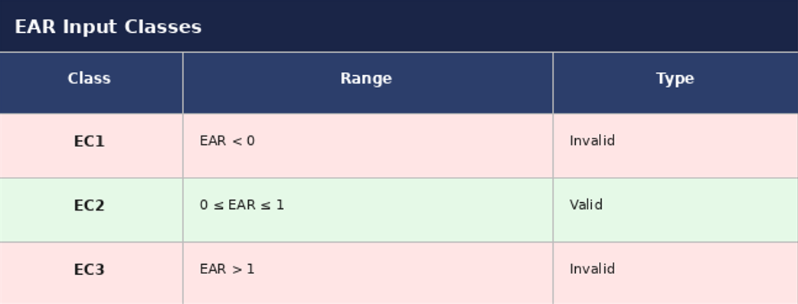

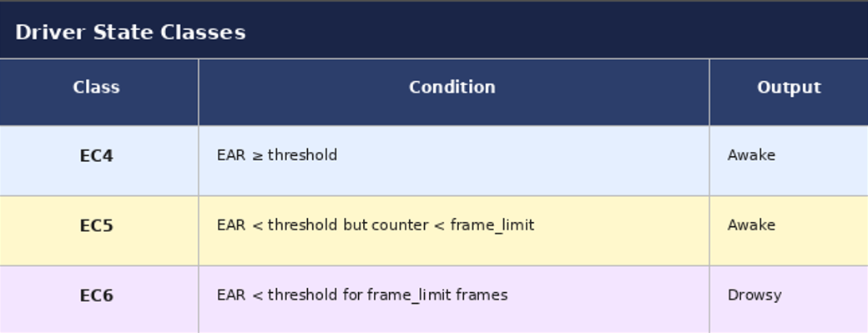

- Step 3: Boundary Value Analysis

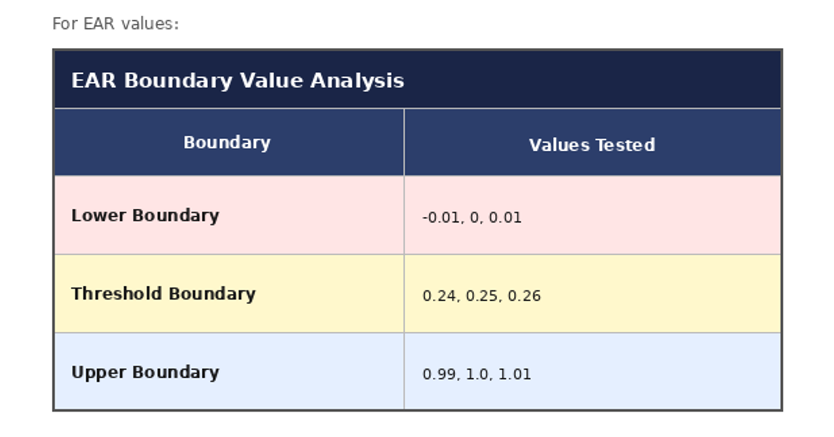

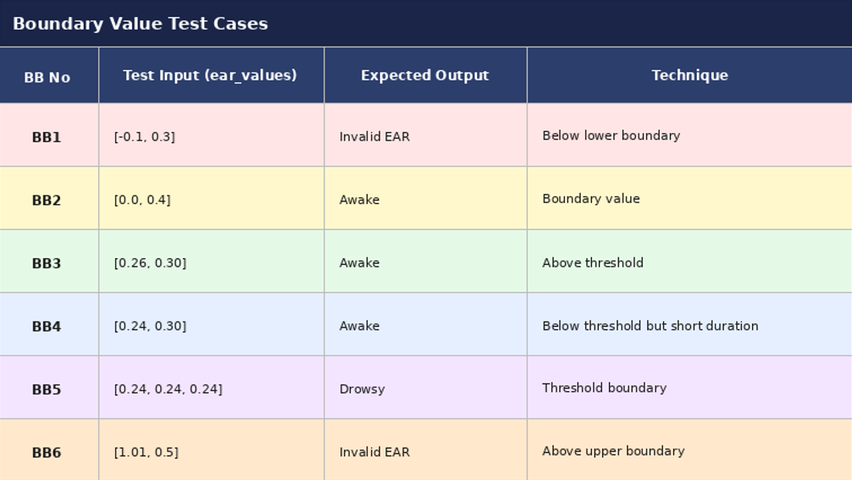

- Step 4: Execute the Black-Box Test Cases

def detect_drowsiness(ear_values, threshold=0.25, frame_limit=3):

counter = 0

for ear in ear_values:

# Validation check
if ear < 0 or ear > 1:
return "Invalid EAR"

# Check if eye is closed
if ear < threshold:
counter += 1
else:
counter = 0

# Check if driver is drowsy
if counter >= frame_limit:
return "Drowsy"

return "Awake"

# ----------------------------------------------------
# Black Box Testing Execution
# ----------------------------------------------------

print ("Test Case 1:", detect_drowsiness([-0.1, 0.3]))
print ("Test Case 2:", detect_drowsiness([0.26, 0.30]))
print ("Test Case 3:", detect_drowsiness([0.24, 0.24, 0.24]))
print ("Test Case 4:", detect_drowsiness([1.01, 0.5]))

CONSOLE OUTPUT: -

Test Case 1: Invalid EAR
Test Case 2: Awake
Test Case 3: Drowsy
Test Case 4: Invalid EAR

6.2 White Box Testing

- Functional Logic Code: -

def detect_drowsiness(ear_values, threshold=0.25, frame_limit=3):

counter = 0
for ear in ear_values:

if ear < 0 or ear > 1: # Validation check
return "Invalid EAR"

if ear < threshold: # Check if eye is closed
counter += 1
else:
counter = 0

if counter >= frame_limit: # Check if driver is drowsy
return "Drowsy"

return "Awake"

- Control Flow Diagram :-
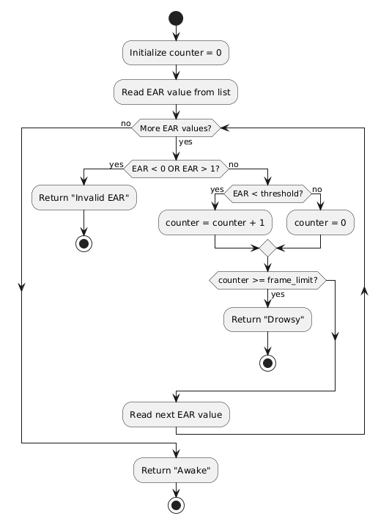

- Cyclomatic Complexity: -

- Method 1: Using Predicate (Decision) Nodes

A predicate node is a node that contains a condition.
From the control flow graph, the following decision nodes are present:
- More EAR values? (Loop condition)
- EAR < 0 OR EAR > 1 (Input validation)
- EAR < threshold (Eye closure check)
- counter ≥ frame_limit (Drowsiness detection)

Therefore,
P = Number of predicate nodes = 4

Using the formula:
V(G) = P + 1
V(G) = 4 + 1
V(G) = 5

- Method 2: Using Edges and Nodes Formula

Another formula used for cyclomatic complexity is:
V(G) = E − N + 2

Where:
E = Number of edges
N = Number of nodes
From the control flow graph:
Number of Nodes (N) = 11
Number of Edges (E) = 14

Therefore,
V(G) = 14 − 11 + 2
V(G) = 5

- Method 3: Using Regions of the Graph

Cyclomatic complexity can also be calculated by counting the number of regions in the flow graph.

From the control flow graph:
Total number of regions = 5

Therefore,
Cyclomatic Complexity V(G) = 5

- Independent Program Paths :-

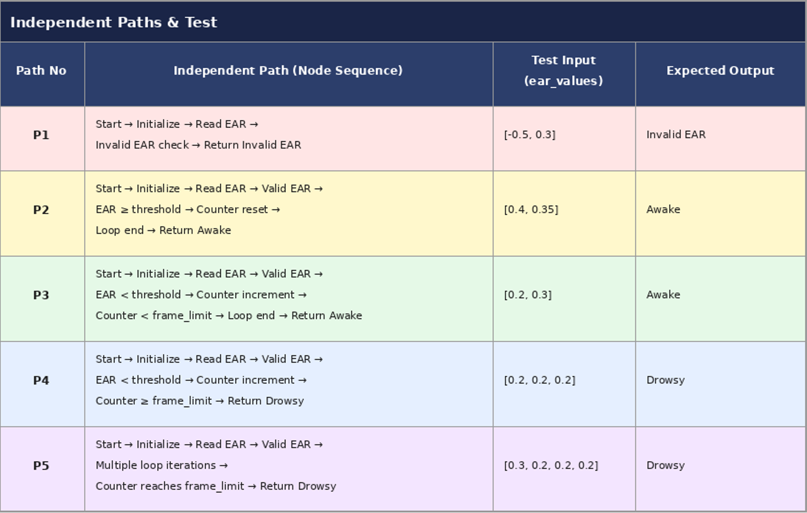

- Unit Testing Code :-

import unittest
from drowsiness_detection import detect_drowsiness

class TestDrowsinessDetection(unittest.TestCase):

def test_invalid_ear(self):
self.assertEqual(detect_drowsiness([-0.5, 0.3]), "Invalid EAR")

def test_awake_driver(self):
self.assertEqual(detect_drowsiness([0.4, 0.35]), "Awake")

def test_counter_increment(self):
self.assertEqual(detect_drowsiness([0.2, 0.3]), "Awake")

def test_drowsy_detected(self):
self.assertEqual(detect_drowsiness([0.2, 0.2, 0.2]), "Drowsy")

def test_multiple_loop_execution(self):
self.assertEqual(detect_drowsiness([0.3, 0.2, 0.2, 0.2]), "Drowsy")

if __name__ == "__main__":
unittest.main()

7. Design Architecture Of System

7.1 Component Diagram

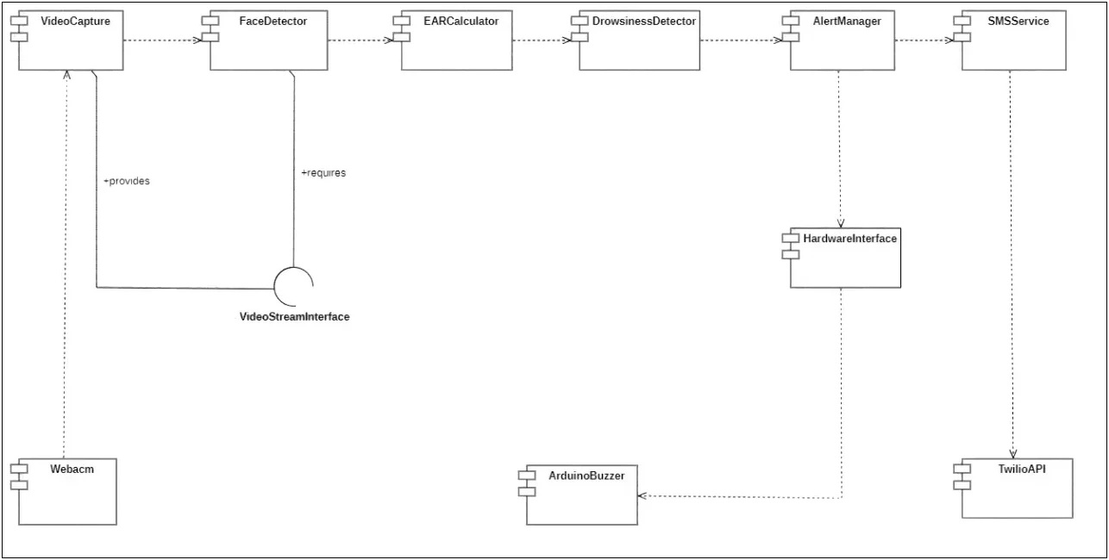

The component diagram captures the full software architecture of the Driver Drowsiness Detection System at a structural level, showing every major software component, the interfaces each one exposes or consumes, and the directional dependencies between them. Reading the diagram from left to right traces the complete data path from raw video input through to the generation of alerts across all three output channels.

The VideoCapture component wraps OpenCV’s VideoCapture API and serves as the system’s sole point of contact with the physical webcam. It exposes a VideoStreamInterface that delivers a continuous sequence of preprocessed grayscale frames to the FaceDetector component. The FaceDetector applies dlib’s HOG-based frontal face detector to locate the driver’s face bounding box, then passes that bounding box to the 68-point shape predictor to extract the full set of facial landmarks. It isolates landmark points 37–42 and 43–48 representing the left and right eyes respectively, and forwards these coordinate sets onward to the EARCalculator component.

The EARCalculator component implements the eye_aspect_ratio() function from ear_utils.py. It receives the six landmark coordinates for each eye, computes the three Euclidean distances using SciPy, and applies the formula EAR = (A + B) / (2.0 * C) where A and B are the vertical distances between upper and lower eyelid pairs and C is the horizontal

eye width. The average EAR across both eyes is returned to the DrowsinessDetector component, which compares this value against the configured threshold. If the EAR remains below the threshold for a number of consecutive frames equal to or exceeding the configured

frame limit, the DrowsinessDetector raises a drowsiness event and passes control to the AlertManager.

Once a drowsiness event is raised, the AlertManager component in alert_manager.py becomes the active controller. It simultaneously dispatches three alert channels: it plays the audio alarm through the system’s audio interface via Playsound or Pygame; it writes a trigger byte to the HardwareInterface over PySerial to activate the ArduinoBuzzer; and, if the cumulative alert count within the rolling time window exceeds the configured threshold, it invokes the SMSService component, which uses the TwilioAPI over HTTPS to dispatch an SMS or WhatsApp message to the registered Emergency Contact.

The component diagram as a whole demonstrates that the system adheres to the principle of single responsibility: every component performs one clearly bounded task and communicates only through defined interfaces. This design makes it straightforward to swap out individual components — for example, replacing the Playsound audio component with a more sophisticated sound engine, or replacing the TwilioAPI integration with a different messaging provider — without touching any other part of the pipeline. It also makes the system straightforward to test in isolation by mocking the interfaces between components.

7.2 Deployment Diagram

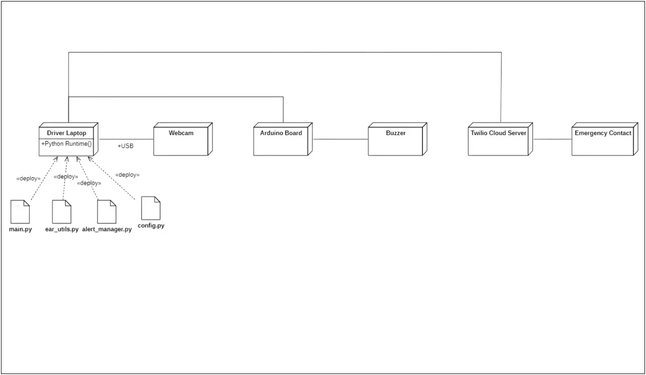

The deployment diagram maps the physical layer of the Driver Drowsiness Detection System, showing exactly which software artifacts are deployed on which hardware nodes and how those nodes communicate with each other. It complements the component diagram by

grounding the abstract software structure in a concrete deployment reality, making the operational environment explicit.

The central node in the deployment is the Driver Laptop, which hosts the complete Python Runtime Environment and all deployed software artifacts: main.py, ear_utils.py, alert_manager.py, and config.py. All processing — from frame capture through landmark extraction, EAR computation, and drowsiness classification — executes locally on this machine. The laptop also carries the pre-trained shape_predictor_68_face_landmarks.dat model file on its local file system, which is loaded into memory once at startup and reused across the entire session.

The Webcam node is attached to the laptop via a USB interface using the UVC protocol. It is the only source of input data for the system, supplying a continuous stream of video frames that main.py reads via OpenCV’s VideoCapture. The webcam node is stateless from the system’s perspective; it simply delivers raw frame data and the laptop bears all responsibility for processing it.

When a drowsiness event is confirmed, alert_manager.py opens a PySerial connection to the Arduino Board node over its virtual COM port and transmits a single trigger byte. The Arduino firmware receives this byte and activates the connected Buzzer for a configurable duration, producing an audible alert that operates independently of the laptop’s audio system.

The Arduino node is entirely passive between drowsiness events, listening on the serial line without consuming meaningful resources on the host machine.
When the cumulative drowsiness alert count within the configured rolling time window exceeds the threshold, alert_manager.py makes an outbound HTTPS call to the Twilio Cloud Server REST API, authenticated using the Account SID and Auth Token from config.py. The Twilio platform then routes an SMS or WhatsApp message to the registered Emergency Contact phone number, delivering a message such as: “Caution: The driver has been consistently drowsy. Please check in.” This remote notification node is the only component in the system that requires internet connectivity, and its failure does not affect any other part of the deployment.

Taken together, the deployment diagram makes clear that the system is designed with a clear separation between local and remote concerns. All safety-critical functions — detection, audio alarm, and hardware buzzer — are confined to the local hardware tier and operate without any network dependency. The remote notification tier is additive and optional, extending the system’s reach to external contacts without compromising the integrity of its core offline safety loop.

8. Conclusion

Road accidents caused by driver fatigue are not an abstract statistic. They represent real lives lost to a problem that is, in principle, preventable. The Driver Drowsiness Detection System was built with that reality in mind. Starting from nothing more than a standard webcam and a

Python environment, this project delivers a working, real-time safety system that can detect the earliest physiological signs of microsleep, warn the driver through multiple simultaneous channels, and notify a registered emergency contact when the situation escalates beyond a single event. The fact that it achieves this using only commodity hardware and open-source libraries is, in many ways, the most important thing about it: it means the barrier to deployment is low enough that this kind of protection is genuinely accessible.
The technical foundation of the system rests on a well-validated scientific insight: the Eye Aspect Ratio. By measuring the ratio of vertical to horizontal eye distances across six landmark points identified by dlib’s 68-point shape predictor, the system can reliably distinguish between a normal blink, which resolves within 150 to 400 milliseconds, and the prolonged eye closure that characterises microsleep. The EAR threshold of 0.25 and the default frame limit of 20 consecutive frames were chosen based on established literature on ocular behaviour during fatigue, and both values are exposed as configurable parameters so the system can be tuned for individual drivers whose anatomy or camera angles may differ from the defaults. This calibration flexibility is one of the design decisions that separates a prototype from a genuinely usable tool.
The alert architecture of the system was designed around a core safety principle: no single point of failure should be able to silence all warnings simultaneously. The audio alarm through the laptop speakers, the hardware buzzer activated via Arduino serial communication, and the remote SMS or WhatsApp notification through the Twilio API each operate through an independent channel. If the computer’s audio is muted, the buzzer fires regardless. If the internet connection drops, the Twilio call fails silently but both local alert channels continue uninterrupted. If the Arduino is not connected, the application logs the absence and proceeds without it. This layered redundancy reflects a genuine understanding of what it means to build a system intended for safety-critical use, where the cost of a missed alert is not a degraded user experience but a potential accident.
The software architecture documented throughout this SRS reflects a commitment to clean, maintainable design. The four-module structure — main.py for the processing loop, ear_utils.py for the EAR function, alert_manager.py for the alert dispatcher, and config.py for all tunable parameters — enforces the single-responsibility principle at the file level. No module reaches into the internal logic of another; they communicate only through well-defined function calls and return values. This means the system is straightforward to test in isolation, easy to extend with new features, and simple to hand off to another developer who has never seen the codebase before. The UML diagrams produced in Chapter 3 — covering use cases, class structure, state transitions, activity flow, sequence interactions, and collaboration patterns across all three modules — provide a complete visual record of this architecture that complements the written specification.
The testing chapter validated the correctness of the core detection logic through two complementary methodologies. Black Box testing using equivalence partitioning and boundary value analysis confirmed that the detect_drowsiness() function handles all four categories of input correctly: invalid EAR values below zero, invalid values above one, valid awake readings above the threshold, and the sustained below-threshold readings that correctly trigger a drowsy result. White Box testing then examined the internal control flow of the same function, producing a control flow graph with 11 nodes and 14 edges, computing a cyclomatic complexity of V(G) = 5 by three independent methods, and identifying all five independent execution paths through the function. Unit tests confirmed that every identified path produces the expected output. A cyclomatic complexity of 5 is a healthy figure for a function of this

responsibility: complex enough to cover all the required decision logic, but simple enough to be fully testable and auditable without specialist tooling.
The non-functional requirements documented in Chapter 5 set concrete, measurable targets for the system’s behaviour beyond functional correctness. The performance requirements demand sustained operation at a minimum of 15 frames per second on standard dual-core hardware, with alarm activation within 200 milliseconds of a drowsiness event being confirmed. The safety requirements mandate graceful degradation across all failure modes so that no software exception can silence the local alert loop. The security requirements ensure that no video footage is ever stored or transmitted, that API credentials are kept out of source control, and that all external communication uses TLS-encrypted HTTPS. Together these requirements describe a system that is not only functionally correct but trustworthy and deployable in a real driving context without introducing new risks.
The project also leaves a clearly marked path for future development. Three extensions stand out as the most impactful and technically natural next steps. First, yawn detection: the same 68-point landmark array already being computed by dlib includes full mouth coordinates (landmarks 49 to 68), making it straightforward to implement a Mouth Aspect Ratio (MAR) calculation analogous to the EAR. Since yawning is one of the earliest and most reliable indicators of fatigue, adding MAR-based detection alongside EAR monitoring would significantly improve the system’s sensitivity without requiring any new hardware or major architectural changes. Second, head pose estimation for distraction detection: if the face landmarks disappear from the frame, or if the head angle deviates significantly from centre for more than a configurable number of frames, the system could issue a distracted driving

alert that goes beyond drowsiness and addresses the broader problem of inattentive driving. Third, driver profile calibration: replacing the single global EAR threshold with a per-driver profile stored locally would allow the system to adapt to the natural variation in eye geometry between individuals, reducing both false positives and false negatives for each specific user.
On a longer horizon, the system’s architecture is well suited to deployment on an embedded platform such as a Raspberry Pi mounted inside a vehicle, transforming it from a laptop application into a purpose-built in-car device. The Python stack, the USB webcam interface, the Arduino serial connection, and the Twilio API integration are all fully compatible with the Raspberry Pi’s hardware and operating system. Such a deployment would bring the system much closer to the form factor of commercial driver monitoring systems found in fleet vehicles and advanced passenger cars, while retaining the cost advantage and transparency of the open-source implementation developed in this project.
This Software Requirements Specification has served its intended purpose: to document every aspect of the Driver Drowsiness Detection System with the rigour and completeness expected of a professional engineering document. From the initial problem statement through the functional requirements, system diagrams, interface specifications, non-functional requirements, testing methodology, architectural design, and this conclusion, the document

provides a self-contained reference that any developer, evaluator, or future contributor can use to understand, assess, extend, or rebuild the system. The project demonstrates that computer vision and embedded systems, applied thoughtfully to a real-world safety problem, can produce solutions of genuine practical value. Driver fatigue will remain a road safety challenge for as long as humans sit behind steering wheels. Systems like this one, built with care and grounded in sound engineering practice, are part of how that challenge gets addressed.

9. Product Metrics/ Function Point Analysis
Task 1 — Identifying Information Domain Values
External Inputs (EIs)
# | EI Name | Description
1 | Webcam Video Feed | Continuous live video frames fed into the detection pipeline from a USB webcam
2 | Configuration Parameters | EAR threshold, frame limit, serial port, and Twilio credentials entered via config.py
3 | Arduino Serial Acknowledgement | Single-byte signal received back from Arduino confirming buzzer activation
4 | Admin Setup Input | Emergency contact number, API keys, and sensitivity values entered by system administrator
Total EIs = 4
External Outputs (EOs)
# | EO Name | Description
1 | Audio Alarm | Wake-up alarm sound played through system speakers upon drowsiness detection
2 | On-Screen Alert Overlay | Red "DROWSINESS ALERT!" warning text rendered on the live OpenCV video window
3 | SMS / WhatsApp Notification | Automated message sent to emergency contact via Twilio API when alert threshold exceeded
4 | Arduino Buzzer Signal | Trigger byte sent over USB serial to Arduino to activate the physical buzzer
5 | Drowsiness Event Log | Timestamped log entry written to local file each time a drowsiness event is confirmed
Total EOs = 5

External Inquiries (EQs)
# | EQ Name | Description
1 | Real-Time EAR Value Display | System immediately retrieves and displays the computed EAR value on screen each frame
2 | Frame Counter Display | Live display of how many consecutive below-threshold frames have been counted
3 | Face Detection Status | System immediately shows whether a face is currently detected in the current frame
Total EQs = 3
Internal Logical Files (ILFs)
# | ILF Name | Description
1 | Drowsiness Event Log File | Local file storing timestamped records of all drowsiness events during a session
2 | Configuration File (config.py) | Stores EAR threshold, frame limit, serial port, API credentials, and contact number
3 | Pre-trained Landmark Model File | shape_predictor_68_face_landmarks.dat loaded and maintained in memory at runtime
Total ILFs = 3
External Interface Files (EIFs)
# | EIF Name | Description
1 | Twilio API Service | External cloud messaging platform used to send SMS and WhatsApp alert notifications
2 | Arduino Firmware Interface | External firmware running on Arduino board that receives and acts on serial trigger signals
3 | OS Audio Interface | External OS audio subsystem (DirectSound on Windows / ALSA on Linux) used for alarm playback
Total EIFs = 3

Information Domain Value Summary
Information Domain Value | Count
External Inputs (EIs) | 4
External Outputs (EOs) | 5
External Inquiries (EQs) | 3
Internal Logical Files (ILFs) | 3
External Interface Files (EIFs) | 3
Total | 18

Task 2 — Calculate UFP (Unadjusted Function Points)
Complexity Weight Reference
Component | Simple | Average | Complex
EI | 3 | 4 | 6
EO | 4 | 5 | 7
EQ | 3 | 4 | 6
ILF | 7 | 10 | 15
EIF | 5 | 7 | 10
Detailed UFP Calculation Table
Comp. | # | Item Name | Complexity | Weight | Justification | Result
EI | 1 | Webcam Video Feed | Complex | 6 | Continuous multi-frame data stream requiring real-time capture and preprocessing every frame | 6
EI | 2 | Configuration Parameters | Simple | 3 | Plain key-value pairs read once at startup, minimal data elements and no processing logic | 3
EI | 3 | Arduino Serial Acknowledgement | Simple | 3 | Single byte signal with no data processing or validation required | 3
EI Subtotal = 16
EI | 4 | Admin Setup Input | Average | 4 | Multiple fields including phone number, API keys and thresholds with basic validation needed | 4
EO | 1 | Audio Alarm | Simple | 4 | Single sound file playback call, no data derivation or formatting required | 4
EO | 2 | On-Screen Alert Overlay | Average | 5 | Rendered on live video frame with text, colour coding, and screen position logic | 5
EO | 3 | SMS / WhatsApp Notification | Complex | 7 | Requires API authentication, message formatting, HTTPS call, response parsing and error handling | 7
EO | 4 | Arduino Buzzer Signal | Simple | 4 | Single trigger byte written over serial port, minimal logic involved | 4
EO Subtotal = 25
EO | 5 | Drowsiness Event Log | Average | 5 | Timestamp formatting, structured log entry writing, and file I/O management required | 5
EQ | 1 | Real-Time EAR Value Display | Average | 4 | EAR computed from pipeline and rendered on screen every frame, moderate data retrieval | 4
EQ | 2 | Frame Counter Display | Simple | 3 | Integer counter simply read from memory and displayed as text, no computation | 3
EQ Subtotal = 10
EQ | 3 | Face Detection Status | Simple | 3 | Boolean yes/no status flag rendered as text on the video window, no processing | 3
ILF | 1 | Drowsiness Event Log File | Average | 10 | Multiple fields per record including timestamp, EAR value, and duration with sequential write | 10
ILF | 2 | Configuration File (config.py) | Simple | 7 | Flat key-value file with few fields, read-only at runtime, no complex structure | 7
ILF Subtotal = 32
ILF | 3 | Pre-trained Landmark Model File | Complex | 15 | Large binary file encoding 68-point landmark model, high data complexity loaded into memory | 15
EIF | 1 | Twilio API Service | Complex | 10 | External REST API requiring authentication, HTTPS, JSON response parsing and error handling | 10
EIF | 2 | Arduino Firmware Interface | Average | 7 | Serial protocol interface with defined baud rate and trigger byte, moderate integration | 7
EIF Subtotal = 22
EIF | 3 | OS Audio Interface | Simple | 5 | Single function call to OS audio subsystem, no data exchange or configuration | 5
UFP COUNT TOTAL |  |  |  |  |  | 105

Task 3 — Calculate CAF and Function Points (Path 1)
Rating Scale
Rating | Meaning
0 | No Influence
1 | Incidental
2 | Moderate
3 | Average
4 | Significant
5 | Essential

14 General System Characteristics — Rated for DDDS
Factor | General System Characteristic | Rating (Fi) | Justification for DDDS
F1 | Reliable backup and recovery | 2 | Log files should survive crashes but no full backup or recovery system is required
F2 | Data communications | 4 | Twilio HTTPS API and Arduino USB serial communication are both significant to the system
F3 | Distributed processing | 2 | Minimal — only the Twilio cloud call involves any distributed processing element
F4 | Performance critical | 5 | Real-time frame processing at 15+ fps with sub-200ms alarm latency is essential to the safety function
F5 | Heavily utilized operational environment | 3 | Runs continuously during a full driving session, placing moderate sustained load on standard hardware
F6 | Online data entry | 3 | Configuration parameters entered before session; live EAR and frame data processed as online input
F7 | Input transaction over multiple screens | 1 | Configuration is single-file based, not multi-screen; minimal influence on the system
F8 | ILFs updated online | 4 | Drowsiness event log file is written in real-time continuously during the live driving session
F9 | Complex inputs, outputs, files or inquiries | 4 | Video frame stream, 68-point landmark coordinates, and Twilio API responses are all significantly complex
F10 | Complex internal processing | 5 | HOG face detection, landmark extraction, EAR formula calculation, and frame counter logic are all essential complexities
F11 | Code designed to be reusable | 3 | ear_utils.py and alert_manager.py are modular and explicitly designed for reuse and extension
F12 | Conversion and installation included | 2 | requirements.txt and setup instructions provided but no data migration or conversion process needed
F13 | Multiple installations in different organizations | 2 | Designed for single-user deployment; can be redeployed but not built for enterprise multi-install
F14 | Designed to facilitate change and ease of use | 4 | config.py centralises all tunable parameters making threshold and credential changes trivial
ΣFi (Sum of all ratings) |  | 44 | 2+4+2+5+3+3+1+4+4+5+3+2+2+4 = 44

CAF Calculation
Formula | CAF = 0.65 + (0.01 × ΣFi)
Substitution | CAF = 0.65 + (0.01 × 44)
Simplification | CAF = 0.65 + 0.44
Result | CAF = 1.09

Function Point Calculation
Formula | FP = UFP × CAF
Substitution | FP = 105 × 1.09
Result | FP = 114.45

Task 4 — Apply Function Points and Calculate Cost (Path 2)
Industry Benchmark Parameters Used
Parameter | Value | Basis
Productivity Rate | 8 hours per FP | Standard benchmark for small-to-medium Python projects with moderate-to-high complexity
Developer Hourly Rate | ₹800 per hour | Realistic junior-to-mid level Python developer rate in India (Tier-2 city, 2025)
Team Size | 1 Developer | Solo academic project
Working Hours per Day | 8 hours | Standard working day
Working Days per Week | 5 days | Standard working week

Step 1 — Estimated Development Hours
Formula | Hours = FP × Productivity Rate
Calculation | Hours = 114.45 × 8
Estimated Hours | 915.6 ≈ 916 hours

Step 2 — Estimated Project Cost
Formula | Cost = Estimated Hours × Developer Hourly Rate
Calculation | Cost = 916 × ₹800
Estimated Project Cost | ₹7,32,800

Step 3 — Estimated Project Duration
Working Days | 916 ÷ 8 = 114.5 ≈ 115 working days
Calendar Duration | 115 ÷ 5 = 23 weeks ≈ 6 months
Estimated Duration | ~6 months

Final Summary
Metric | Value
Total Components Identified | 18
UFP (Unadjusted Function Points) | 105
ΣFi (Sum of all 14 CAF factors) | 44
CAF (Complexity Adjustment Factor) | 1.09
FP (Final Function Points) | 114.45
Productivity Rate | 8 hours / FP
Developer Rate | ₹800 / hour
Estimated Development Hours | 916 hours
Estimated Project Cost | ₹7,32,800
Estimated Project Duration | ~6 months

Interpretation
The Driver Drowsiness Detection System has a functional size of 114.45 Function Points after adjusting for its high real-time processing complexity, performance criticality, and multi-channel alert architecture. This places it in the small-to-medium software project category. Based on standard industry productivity benchmarks and realistic Indian developer rates, the estimated development effort is 916 hours at a total cost of ₹7,32,800, deliverable over approximately 6 months by a single developer. These estimates are consistent with the scope of a well-defined final year engineering project that integrates computer vision, embedded hardware, and cloud APIs into a unified safety application.

9. Empirical Estimation Models (COCOMO) :-
The COCOMO (Constructive Cost Model), proposed by Barry Boehm, is a regression-based empirical estimation model that predicts software development effort, time, and cost using Lines of Code (LOC) as the primary input. It complements the Function Point Analysis by converting the computed Function Points into a LOC estimate and applying COCOMO formulas to produce concrete staffing, schedule, and cost outputs. Both the Basic and Intermediate COCOMO models are applied below.
Project Baseline
Function Points (FP) from FPA = 114.45
Conversion Used = 1 FP ≈ 10 Lines of Code (LOC) [Standard Industry Conversion]
LOC = 114.45 × 10 = 1,144.5
KLOC = 1,144.5 / 1000 = 1.1445 KLOC
Project Type = Organic — solo developer, Python/OpenCV familiar environment, well-scoped academic safety project.
Basic COCOMO Model
The Basic COCOMO model uses only KLOC to compute a quick first-pass estimate of effort and schedule. The formulas applied are:
Effort (E) = A × (KLOC)^B
Time (T) = C × (Effort)^D
Persons Required = Effort / Time
Constants for Organic project type (from COCOMO standard):
Software Project | A | B | C | D
Organic (DDDS) | 2.4 | 1.05 | 2.5 | 0.38
► Effort Estimation
Formula: E = A × (KLOC)^B = 2.4 × (1.1445) ^1.05
E = 2.4 × 1.1524
E = 2.77 Person-Months (PM)

► Development Time Estimation
Formula: T = C × (Effort)^D = 2.5 × (2.77) ^0.38
T = 2.5 × 1.5065
T = 3.77 Months
► Persons Required
Persons = Effort / Time = 2.77 / 3.77 = 0.73 ≈ 1 Person
► Total Project Cost
Assuming: Cost per Person-Month = ₹14,000 (derived from ₹800/hr × 8 hrs/day × 22 working days)
Cost = Effort × Cost per PM = 2.77 × ₹14,000
Cost = ₹38,780
Basic COCOMO Results Summary:
Parameter | Value | Unit
Effort (E) | 2.77 | Person-Months
Development Time (T) | 3.77 | Months
Persons Required | ∼1 | Person
Cost per Person-Month | ₹14,000 | INR
Total Project Cost | ₹38,780 | INR
Intermediate COCOMO Model
The Intermediate COCOMO model refines the Basic estimate by multiplying base effort by an Effort Adjustment Factor (EAF), which is the product of 15 Cost Driver ratings reflecting the real technical and personnel characteristics of the project. For Organic type under the Intermediate model, the constant A changes to 3.2. Formulas:
Effort (E) = (A × (KLOC)^B) × EAF where A = 3.2, B = 1.05
Time (T) = C × (Effort)^D where C = 2.5, D = 0.38
EAF = Product of all 15 Cost Driver values
Cost Driver Ratings for DDDS: -
Each cost driver is rated on the scale: Very Low / Low / Nominal / High / Very High / Extra High. A Nominal rating carries a value of 1.00 (no effect). Values above 1.00 increase effort; values below 1.00 decrease it.
# | Cost Driver | Rating | Value | Justification for DDDS
1 | Required Software Reliability | High | 1.15 | Safety-critical system; a missed drowsiness alert could directly cause a road accident
2 | Database Size | Low | 0.94 | Minimal stored data — only an event log file and config.py; no large relational database
3 | Product Complexity | High | 1.15 | HOG face detection, 68-point landmark extraction, EAR formula, and frame counter logic combined
4 | Runtime Performance Constraints | Very High | 1.30 | Must process 15+ fps in real-time with sub-200ms alarm latency — essential to the safety function
5 | Memory Constraints | Nominal | 1.00 | Standard laptop RAM (4 GB+) is sufficient; no tight embedded memory constraint present
6 | VM Environment Volatility | Low | 0.87 | Python/OpenCV environment is stable; no frequent OS or runtime changes expected during development
7 | Required Turnabout Time | Nominal | 1.00 | Standard academic development cycle; no unusually tight turnaround time required
8 | Analyst Capability | High | 0.86 | Solo developer with strong analytical capability covering all analysis, design and testing responsibilities
9 | Software Engineering Capability | Nominal | 1.00 | Standard SE practices applied; modular design with config.py separation follows established methodology
10 | Applications Experience | Low | 1.17 | Limited prior experience with dlib, PySerial and Twilio API integration in this specific domain
11 | Virtual Machine Experience | Nominal | 1.00 | Standard Python 3.8+ environment; no unusual virtualisation or containerisation required
12 | Programming Language Experience | High | 0.95 | Developer has solid Python experience; OpenCV and NumPy syntax is familiar from prior coursework
13 | Use of Software Tools | High | 0.91 | Strong tooling — OpenCV, dlib, PySerial, Twilio SDK and pip environment are all well-supported
14 | Application of SE Methods | Nominal | 1.00 | Standard SE methodology applied; no advanced formal methods or model checking used
15 | Required Development Schedule | Nominal | 1.00 | Academic project timeline; no compression or extension of the development schedule needed
EAF = 1.15 × 0.94 × 1.15 × 1.30 × 1.00 × 0.87 × 1.00 × 0.86 × 1.00 × 1.17 × 1.00 × 0.95 × 0.91 × 1.00 × 1.00 = 1.2231
► Effort Estimation
E = (3.2 × (1.1445) ^1.05) × EAF = (3.2 × 1.1524) × 1.2231
E = 3.6877 × 1.2231
E = 4.51 Person-Months (PM)
► Development Time
T = 2.5 × (4.51) ^0.38 = 2.5 × 1.7591
T = 4.40 Months
► Persons Required
Persons = 4.51 / 4.40 = 1.025 ≈ 1 Person (consistent with a solo academic project)
► Total Project Cost
Cost = 4.51 × ₹14,000
Cost = ₹63,140

Intermediate COCOMO Results Summary:
Parameter | Value | Unit
EAF (Effort Adjustment Factor) | 1.2231 | —
Effort (E) | 4.51 | Person-Months
Development Time (T) | 4.40 | Months
Persons Required | ∼1 | Person
Cost per Person-Month | ₹14,000 | INR
Total Project Cost | ₹63,140 | INR
The Intermediate COCOMO estimate of 4.51 Person-Months, 4.40 Months development time, and a total cost of ₹63,140 provides a more accurate projection than the Basic model because it accounts for the specific characteristics of the Driver Drowsiness Detection System: the elevated reliability requirement of a safety-critical application, the very high runtime performance constraint of real-time 15+ fps processing, the product complexity of HOG face detection and 68-point landmark extraction, and the limited applications experience of a solo developer working with dlib and PySerial for the first time. The EAF of 1.2231 correctly reflects that these factors add meaningful effort beyond the baseline KLOC estimate. The result of approximately 1 person working for 4 to 5 months is entirely consistent with the scope described throughout this SRS document and with the reality of a well-defined final year engineering project integrating computer vision, embedded hardware, and cloud APIs into a unified safety application.

